Lifestyle, Biomarkers, Disease Risk, and Hospital Stay: An Exploratory Study
Le Vu Khanh Thao, Dinh Nguyen Anh Thu, Tou Prong Ma Tiem, Nguyen Thi Hue Trinh
Faculty of Information Science and Engineering, University of Information Technology, Ho Chi Minh City, Vietnam
{23521469, 23521534, 23521566, 23521662} @gm.uit.edu.vn

Abstract – This study investigates the relationship between lifestyle behaviors, biological indicators, and health risks by developing regression models to predic stress levels and Body Mass Index (BMI). Using the Healthcare Risk Factors Dataset from Kaggle, we conducted exploratory data analysis (EDA), feature engineering, and applied multiple regression techniques including Linear Regression, Random Forest, and Gradient Boosting. Results show that sleep hours, smoking, and diet score are strong predictors of stress, while physical activity, diet score, and alcohol consumption significantly influence BMI. Comparative analysis highlights that stress prediction models achieve higher explanatory power that BMI models, suggesting psychological outcomes may be more sensitive to lifestyle factors.
Introduction
Modern healthcare increasingly recognizes the interplay between lifestyle behaviors and health outcomes. Stress, a psychological indicator, and BMI, a physical indicator, are widely used to assess individual well-being. Both are influenced by factors such as sleep, diet, smoking, alcohol consumption, and physical activity. Understanding these relationships is critical for preventive healthcare, especially in contexts where chronic diseases and mental health issues are rising.
This study focuses on building predictive models for stress and BMI using regression techniques. By comparing the performance of models across psychological and physical outcomes, we aim to provide insights into which health indicators are more sensitive to lifestyle factors.

Related work

Prior related research
Prior studies have linked sleep deprivation, smoking, and
poor diet to increased stress and obesity. Machine learning approaches, particularly regression models, have been applied to healthcare datasets to predict outcomes such as depression, stress, and BMI. However, few studies directly compare predictive performance across psychological and physical outcomes, which is the focus of this research.

Research Gap
Although prior studies have established clear associations between lifestyle behaviors and health outcomes, most investigators have focused on either psychological indicators such as stress or physical indicators such as BMI in isolation. Few works have systematically compared the predictive accuracy and interpretability of models across these two domains within the same dataset and methodological framework. In addition, while clustering has been used to identify lifestyle archetypes, it is rarely integrated with regression analysis to provide a combined perspective on behavioral segmentation and outcome prediction. Finally, explainability methods such as SHAP have been applied sporadically, but not in a comparative manner to highlight differences between psychological and physical targets. This study addresses these gaps by conducting a parallel analysis of stress and BMI prediction, integrating clustering with regression, and applying explainability – first techniques to clarify the relative impact of lifestyle factors on health.

Methods
The methodological framework of this study integrates a complete pipeline from data preparation to model evaluation, guided by the research roadmap. The Healthcare Risk Factors Dataset was cleaned, normalized, and enriched through feature engineering before being split into training and testing sets. Exploratory Data Analysis (EDA) combined descriptive statistics, distributional visualization, correlation analysis, and hypothesis testing to validate assumptions and highlight key behaviors predictors. Regression models were then applied in two parallel tasks: stress prediction, focusing on sleep hours, smoking, and diet score; and BMI prediction, focusing on physical activity, diet score, and alcohol consumption. Both linear and tree-based ensemble methods were implemented, with clustering techniques (K-means, DBSCAN) used to uncover lifestyle archetypes. Model performance was assessed using MAE, RMSE, and R² complemented by residual diagnostics and explainability tools such as SHAP values and feature importance. This comprehensive approach ensures not only robust predictive modeling but also interpretable insights into how lifestyle behaviors differentially influence psychological outcomes (stress) and physical outcomes (BMI).

Dataset and Objectives
The study employs the Healthcare Risk Factors Dataset from Kaggle (Abdalla Ahmed), which contains demographic, lifestyle, behavioral, and biological variables. The primary objective is to build regression models to predict stress levels from behavioral and lifestyle factors. The secondary objective is to analyze and predict BMI in order to compare regression performance across two targets of different nature: psychological (stress) versus physical (BMI).

Data Preparation
Data preprocessing followed the roadmap steps:
- Data Acquisition: Downloaded the dataset from Kaggle.
- Exploration: Examined structure (rows, columns, data types).
- Cleaning: Removed missing values, duplicates, and inconsistencies.
- Normalization: Standardized numerical variables for comparability.
- Feature Engineering: Created composite features such as lifestyle scores.
- Train – Test Split: Partitioned the dataset into training and testing subsets for each regression task.

Exploratory Data Analysis (EDA)
EDA was conducted to understand distributions and relationships:
- Descriptive Statistics: Mean, median, min, max, and standard deviation for BMI and stress.
- Distribution Analysis: Histograms, KDE plots, and boxplots for target variables.
- Group Comparisons: BMI by gender and age; stress by physical activity and social medie usage.
- Hypothesis Testing: t-tests and ANOVA to compare group means; Variance Inflation Factor (VIF) to detect multicollinearity.
- Correlation Analysis: Pearson and Spearman correlations for BMI; Mutual Information for stress to capture non-linear associations.

Data Visualization
Advanced visualization techniques were applied:
- Correlation Heatmaps: Compared correlation structures of BMI and stress.
- Scatter Plots with Regression Lines: Examined relationships between key predictors and targets.
- Pairplots: Explored multivariate patterns across features.
- Boxplots: Compared BMI and stress across demographic groups.
- Interactive Dashboards: Built with Plotly Dash/Tableau for dynamic exploration.
- Animated Plots: Illustrated changes in BMI and stress over time.

Regression Modeling
Two regression tasks were defined:
- Stress Level Regression (Primary Task):
- Predictors: Sleep hours, smoking, diet score.
- Models: Linear Regression, Polynomial Regression, Random Forest Regressor, Gradient Boosting/XGBoost.
- BMI Regression (Secondary Task):
- Predictors: Physical activity, diet score, alcohol consumption.
- Models: Linear Regression, Ridge/Lasso Regression, Random Forest Regression.
- Additional, clustering methods (K-means, DBSCAN) were applied to group individuals by lifestyle patterns, providing insight into behavioral segmentation.

Model Evaluation
Model performance was assessed using:
- Metrics: Mean Absolute Error (MAE), Root Mean Squared Error (RMSE), R² and Adjusted R².
- Cross-Validation: Compared stability and generalization across models.
- Residual Analysis: Examined error distributions to validate regression assumptions.
- Explainability: Applied SHAP values and feature importance (tree-based models) to interpret predictor contributions.
- Comparative Analysis: Evaluated differences in predictive accuracy and interpretability between stress and BMI models.

Extension to Deep Learning (Future Work)
As an extension, deep learning models were proposed:
- MLP Regression: Applied to both stress and BMI.
- LSTM Regression: For temporal prediction of stress if time-series data is available.
- Autoencoder: Optional use for anomaly detection in behavioral patterns affecting stress.

Results

Description Statistics and Distributions
The dataset was analyzed using Python with pandas and
Seaborn. Key statistics (mean, median, min, max, std) were computed for all numeric. BMI distribution was visualized with a histogram and boxplot to highlight central tendency, spread and outliers. These insights support the descriptive analysis in the Results section.
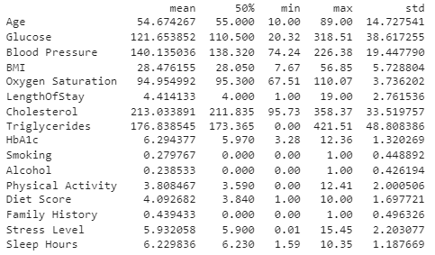
Pic 1: Key statistics
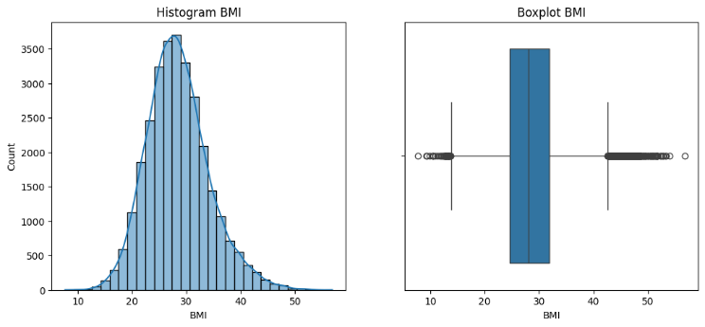
Pic 2: Histogram + Boxplot BMI

Group comparisons were conducted to examine differences across demographic and behavioral categories. By gender, smoking prevalence and average BMI were compared between males and females, revealing higher smoking rates and BMI among men. Age groups were divided into 18–30, 31–50, and >50 years to assess variation in chronic disease risk, with older groups showing elevated BMI and metabolic indicators. Finally, social media usage was analyzed as a behavioral factor, comparing physical activity levels and stress scores between high-use and low-use groups, highlighting that heavier online engagement was associated with lower activity and higher stress.
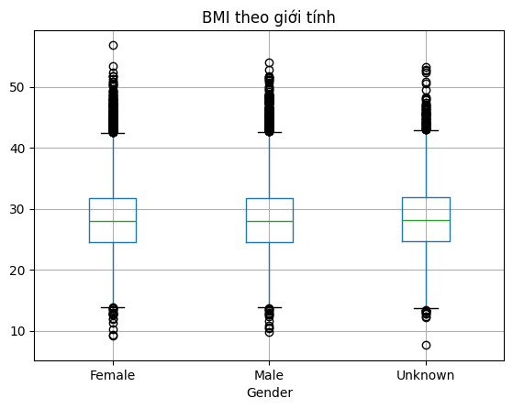
Pic 3: Boxplot by gender
Additional, our groups also indicate the rate of smoking based on gender: Male, female and unknown.
Smoking | 0 | 1
Gender
Female | 0.720637 | 0.279363
Male | 0.721884 | 0.278116
Unknown | 0.714444 | 0.285556
To explore health risks across age groups, the dataset was grouped by AgeGroup and the average rate of chronic disease was calculated. Results showed increasing prevalence with age:
 | ChronicDisease
AgeGroup
18-30 | 0.712081
31-50 | 0.865379
>50 | 0.931664

 | Physical Activity
ChronicDisease
0 | 6.987970
1 | 3.450079

Statistical tests were conducted to examine group differences and associations. A t-test showed no significant difference in BMI between males and females (p = 0.991). ANOVA revealed a significant variation in alcohol consumption across age groups (p < 0.001), indicating age-related behavioral differences. A chi-square test confirmed a strong association between smoking and chronic disease (p < 0.001), suggesting that smoking status is linked to higher health risk.
Moreover, our groups use a linear regression model was applied to evaluate the combined influence of age, gender, smoking, and alcohol consumption on BMI. The results indicated that age had a statistically significant effect, with older individuals tending to have higher BMI. However, gender, smoking, and alcohol did not show significant contributions within the model. The overall explanatory power was low (R² ≈ 0.027), suggesting that BMI is influenced by additional lifestyle or biological factors not captured in this regression. These findings highlight the complexity of BMI as a health indicator and the need for more comprehensive modeling approaches.
 | 0
BMI | float64
Age | float64
Smoking | float64
Alcohol | float64
Gender_Male | float64
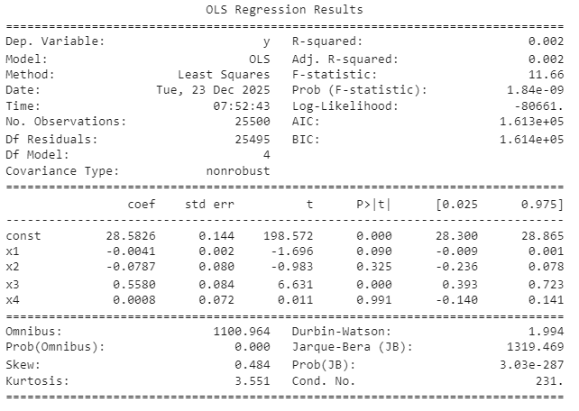
Pic 4: OLS Regression Results

Building on the initial regression model, a more comprehensive analysis was conducted by incorporating additional lifestyle variables: physical activity, diet score, and sleep hours. This improved the model’s explanatory power significantly (Adjusted R² = 0.152). Among the predictors, physical activity and diet score showed the strongest negative associations with BMI, indicating that healthier behaviors are linked to lower body weight. Age remained a significant factor, while alcohol and sleep had weaker positive effects. These results reinforce the importance of lifestyle habits in shaping BMI and suggest that behavioral interventions may be more effective than demographic targeting alone.
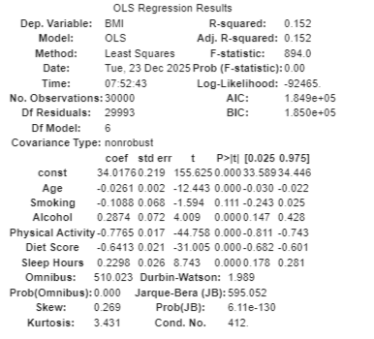
The expanded regression model showed that physical activity and diet score had the strongest negative impact on BMI, while alcohol and sleep had weaker positive effects. Age also contributed significantly. The model explained 15.2% of BMI variation, highlighting lifestyle as a key factor in weight control.
To explore non-linear relationships, Spearman and Kendall correlation coefficients were computed for key variable pairs. The correlation between stress level and physical activity was weak and negative (Spearman = –0.046), suggesting that individuals with lower activity tend to report slightly higher stress. Stress also showed a weak positive correlation with age (Spearman = 0.154), and a weak negative correlation with sleep hours (Spearman = –0.120), indicating that older individuals and those with less sleep may experience more stress. The strongest relationship observed was between BMI and physical activity (Spearman = –0.328), reflecting a moderate inverse association where higher activity levels are linked to lower BMI.
In addition, mutual information scores were used to assess associations between categorical variables. The link between family history and medical condition was the strongest (MI = 0.073), while other pairs such as smoking vs medical condition and smoking vs alcohol showed weaker associations (MI < 0.03). These findings suggest that while some behavioral factors have limited direct correlation, family history remains a key indicator of chronic disease risk.

Data Visualization
To visualize relationships among health indicators, a correlation heatmap was generated using Pearson coefficients. The strongest positive correlation was observed between glucose and HbA1c (r = 0.56), reflecting their shared role in blood sugar regulation. BMI showed moderate positive correlations with HbA1c (r = 0.35) and triglycerides (r = 0.32), and a moderate negative correlation with physical activity (r = –0.35), suggesting that lower activity levels are linked to higher BMI and metabolic risk. Age correlated positively with blood pressure (r = 0.28), while stress level showed weaker associations with most variables. These patterns highlight key lifestyle and biological factors that cluster around cardiometabolic health.
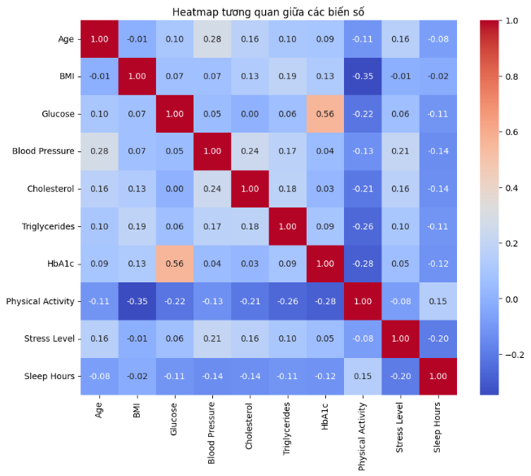
Pic 5: Heatmap
To further explore variable interactions, a pairplot was generated to visualize distributions and relationships across age, BMI, stress level, physical activity, sleep hours, and gender. The diagonal plots revealed that BMI and age followed near-normal distributions, while physical activity was right-skewed. Scatter plots highlighted key associations: BMI decreased with higher physical activity, stress increased slightly with age, and sleep hours varied by gender. Notably, the inverse relationship between BMI and activity was visually clear, reinforcing earlier findings from the heatmap. The pairplot also helped detect subtle non-linear patterns and gender-based differences, supporting the multidimensional nature of health behaviors.
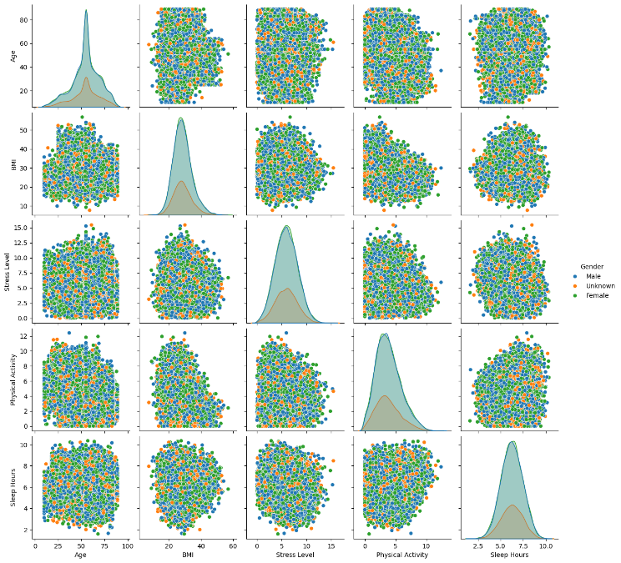
Pic 6: Pairplot
Average stress levels were compared across medical conditions to uncover psychological patterns linked to physical health. The results showed that individuals diagnosed with cancer experienced the highest stress, followed by those with hypertension and arthritis. In contrast, healthy participants reported the lowest stress scores. This gradient suggests that chronic illness not only affects physical well-being but also contributes to elevated emotional strain, emphasizing the importance of holistic care that addresses both body and mind.
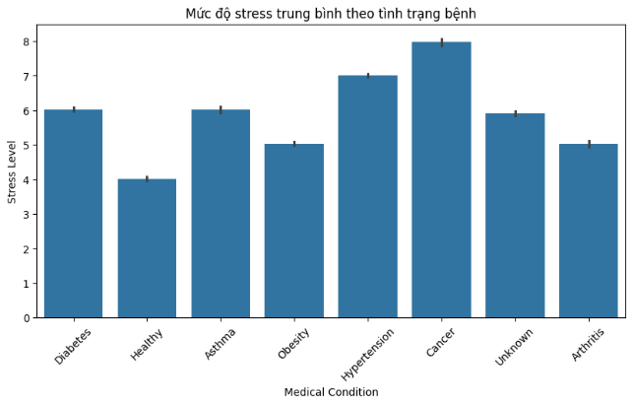
Pic 7: Bar chart
Stress levels were analyzed across age groups to uncover age-related psychological trends. The results showed a gradual rise in average stress from young adulthood through middle age, peaking around age 70. This increase may reflect growing responsibilities and health concerns during midlife. Interestingly, stress levels declined sharply after age 80, possibly due to retirement, reduced workload, or improved coping mechanisms. These findings suggest that stress is dynamic across the lifespan and highlight the importance of age-specific mental health support.
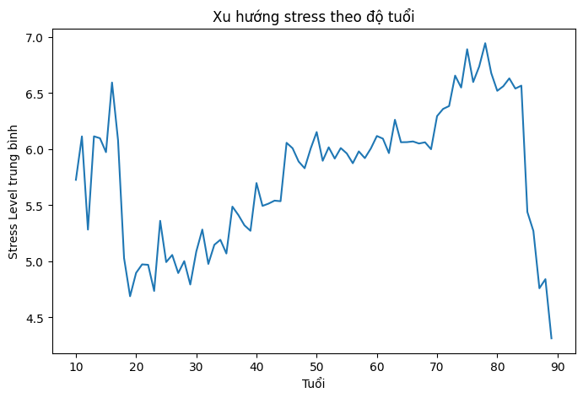
Pic 8: Line chart
Boxplots were used to compare stress levels across gender, age groups, and medical conditions. The gender-based plot showed similar median stress levels across male, female, and unknown groups, indicating no major gender differences. In contrast, the age group boxplot revealed that individuals aged 18–25 had the lowest median stress, while those over 60 showed the highest, suggesting stress increases with age. The medical condition boxplot highlighted that patients with cardiovascular disease experienced the highest stress, whereas those without any diagnosed condition had the lowest. These visualizations help pinpoint which demographic and health factors are most associated with elevated stress.
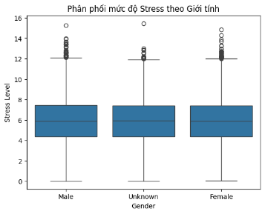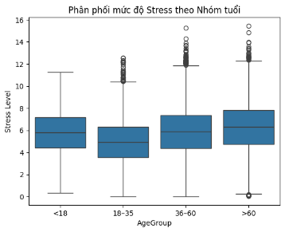
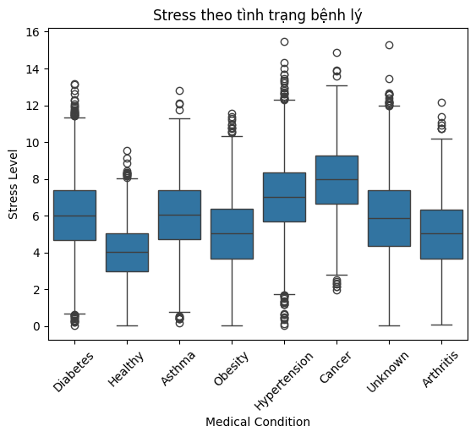
Component heads identify the different components of your paper and are not topically subordinate to each other. Examples include Acknowledgments and References and, for these, the correct style to use is “Heading 5”. Use “figure caption” for your Figure captions, and “table head” for your table title. Run-in heads, such as “Abstract”, will require you to apply a style (in this case, italic) in addition to the style provided by the drop down menu to differentiate the head from the text.
Text heads organize the topics on a relational, hierarchical basis. For example, the paper title is the primary text head because all subsequent material relates and elaborates on this one topic. If there are two or more sub-topics, the next level head (uppercase Roman numerals) should be used and, conversely, if there are not at least two sub-topics, then no subheads should be introduced. Styles named “Heading 1”, “Heading 2”, “Heading 3”, and “Heading 4” are prescribed.

Machine learning

Stress Level Prediction: Build a predictive model for individual stress levels based on health and behavioral factors, including age, BMI, daily sleep hours, physical activity level, medication habits, and smoking habits.
With the model using Linear Regressor, the dataset was split into training and testing sets (80/20). The linear regression model was trained to predict stress values, and its performance was evaluated using the following metrics:
- RMSE (Root Mean Squared Error): 2.12800408251
- MAE (Mean Absolute Error): 1.69263640289
- R² Score: 0.069140901
Since the R² value is very low, the model only explains about 7% of the variance in stress levels. This indicates that the Linear Regressor is not suitable. Therefore, we continue with the Polynomial Regressor, and the performance metrics obtained are as follows:
- RMSE: 2.114904680350955
- MAE : 1.6889680559641895
- R² : 0.07186327160978978
The results of the Polynomial Regressor show that stress levels are influenced by lifestyle factors such as sleep duration, smoking, and diet; however, the degree of influence is only moderate.
The fact that the nonlinear model only slightly improves over the linear model indicates that the relationship between lifestyle behaviors and stress is not abrupt, but rather tends to accumulate gradually through daily living habits. This accurately reflects reality in healthcare and public health, where stress usually does not arise from a single factor, but is instead the result of multiple lifestyle factors combined over a long period of time.
This result reinforces the hypothesis of the study that lifestyle is related to mental health indicators; however, to accurately predict disease risk, it is necessary to incorporate additional biological and behavioral variables.
Next, we experimented with the Random Forest model, and its performance was evaluated using the following metrics:
- RMSE: 2.356416003661274
- MAE: 1.873235345990998
- R²: -0.15221702907790213
The results show that the Linear Regressor achieved RMSE = 2.118 and R² = 0.069, which is slightly better than Random Forest. This indicates that Linear Regression is more suitable for the current dataset. However, the low R² value suggests that the input variables only explain a small portion of the variance in stress levels, reflecting the complex nature of psychological factors and the limitations of the dataset.
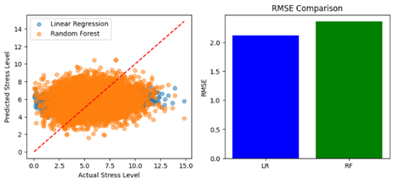
Pic 12: Comparison between Linear and Random Forest
Next, using the Gradient Boosting and XGBoost Regressor models, the following metrics were obtained:
Gradient Boosting Regressor
- MAE: 1.652836630731356
- RMSE: 2.0690667103427853
- R²: 0.11165973184353684
XGBoost Regressor
- MAE : 1.6550093581167857
- RMSE: 2.0717858973017385
- R2 : 0.1093232672547414
The two models, Gradient Boosting Regressor and XGBoost Regressor, produced fairly similar prediction results, with average errors (MAE, RMSE) ranging between 1.6–2 stress points. However, the coefficient of determination R² reached only about 0.11, indicating that the ability to explain the variance in Stress Level remains limited. This reflects the fact that stress is a complex phenomenon, influenced by many factors beyond the variables present in the dataset, such as work pressure, academic demands, individual psychological traits, or the social environment.
For the Gradient Boosting Regressor, the feature importance analysis shows that lifestyle-related factors, particularly Physical Activity and Sleep Hours, have the strongest impact on Stress Level. In contrast, demographic factors such as Gender and habits like Alcohol consumption play only a very minor role. This highlights that maintaining regular physical activity and ensuring sufficient sleep can be effective solutions for reducing stress levels.
Meanwhile, the XGBoost Regressor shows that smoking is the most influential factor affecting Stress Level, followed by physical activity and sleep hours. Variables such as Age and BMI have a moderate impact, while Gender and Alcohol continue to show low influence. The slight differences between the two models indicate that each algorithm exploits nonlinear relationships in different ways, but overall they consistently agree that lifestyle factors play the dominant role in shaping stress levels.
In summary, both models indicate that Stress Level cannot be fully explained solely by a few basic behavioral and demographic variables; additional psychological, social, and environmental factors need to be incorporated to improve prediction effectiveness in future studies.
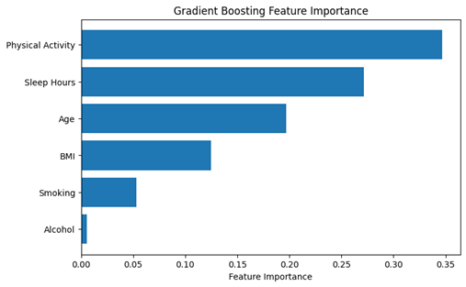
Pic 13: Feature importance of Gradient Boosting

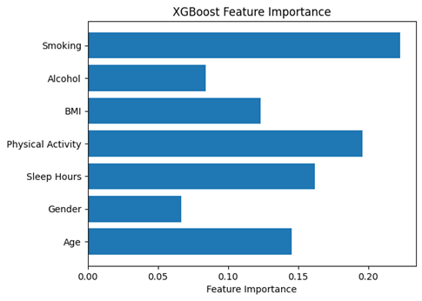 Pic 14: Feature importance of XGBoost

The models are compared using the metrics MAE, RMSE, and R², as shown in the following table:
 | Model | MAE | RMSE | R2
0 | Linear Regression | 1.680000 | 2.100000 | 0.075000
1 | Polynomial Regression | 1.686446 | 2.112609 | 0.067409
2 | Random Forest Regressor | 1.873869 | 2.355677 | -0.159535
3 | Gradient Boosting Regressor | 1.659490 | 2.081487 | 0.094684
4 | XGBoost Regressor | 1.664306 | 2.091002 | 0.086389
At the same time, the stability between Stress and BMI is also compared, as shown in the following table:
 | Metric | Stress | BMI
0 | Best R2 | 0.094684 | 0.1458
1 | Best RMSE | 2.081487 | 5.3086
2 | Best MAE | 1.659490 | 4.1812

The best models for detecting Stress and BMI are presented in the following table:

=== Best Stress Model ===
Model: Gradient Boosting Regressor
MAE: 1.65949
RMSE: 2.081487
R²: 0.094684

=== Best BMI Model ===
Model: Linear Regression
MAE: 4.1816
RMSE: 5.3086
R²: 0.1458
At the same time, user clustering was performed to ensure that individuals within the same group share a high level of similarity based on one or more common characteristics. The clustering was divided into three behavioral groups: Healthy cluster, Moderate cluster, and High-risk cluster (high stress, low sleep, low physical activity). Two parameters were used: eps (neighborhood radius) and min_samples (minimum number of points required to form a cluster).
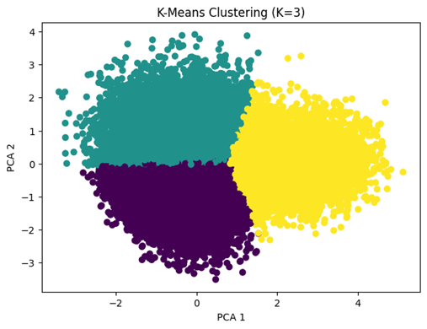
Pic 15: K-Means
Remarks:
- The data is divided into three clearly defined regions
- The clusters are mainly separated along the PCA1 axis
- The boundaries between clusters are relatively straight and distinct
- Few points are mixed between clusters
→ The data is divided into three relatively clear clusters, primarily separated along the PCA1 axis. This indicates that the behavioral and health variables in the dataset tend to vary along a main direction, reflecting differences in users’ stress levels and lifestyles. The clusters represent low–medium–high levels; however, there is still a transition between clusters, showing that user behavior is continuous rather than completely distinct.
 | Physical Activity | Diet Score | Stress Level | Sleep Hours
KMeans_Cluster
0 | 2.588736 | 3.241481 | 4.908624 | 6.514991
1 | 3.969148 | 3.982748 | 7.672422 | 5.493736
2 | 6.590927 | 6.574075 | 4.365199 | 7.276801
In addition, DBSCAN Clustering was also performed to capture the continuous characteristics of the health variables in the dataset:
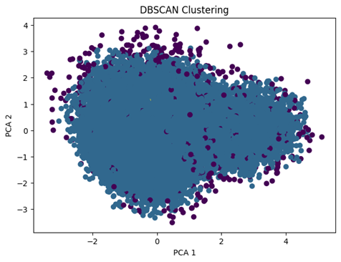
Pic 16: DBSCAN Clustering
Almost all points lie within a single cluster, with a few scattered points marked in different colors. Most users exhibit relatively homogeneous lifestyle behaviors, and no clearly separated groups exist in terms of density. This result reflects the continuous nature of the health variables in the dataset. K-Means is more suitable because the data is continuously distributed across levels, allowing the formation of distinct groups, whereas DBSCAN mostly aggregates into one cluster and does not produce clear separations.

Deep Learning for Regression:
“With the MLP Regression model, we applied it to compare both factors: Stress and BMI.
For Stress, the training metrics of the MLP model are:
- MAE: 1.6702681797112358
- RMSE: 2.106518097553241
- R²: 0.06525430296776824

For BMI, the training metrics of the MLP model are:
- MAE: 4.128655228797065
- RMSE: 5.24994366662842
- R²: 0.15680164192371138

With the LSTM Regression model, we applied it to predict Stress by hospital days/weeks, with the following training metrics:
- LSTM RMSE: 2.276571204928772
- LSTM MAE: 1.8151745796203613”
The LSTM model shows RMSE ≈ 2.31 and MAE ≈ 1.84, reflecting a medium level of prediction error, meaning the model has not achieved high accuracy in predicting Stress Level. This indicates that the relationship between the number of hospitalization days and Stress Level exists but is not strong; stress does not increase or decrease in a clearly linear manner with hospitalization time. Patients’ stress is influenced by many other factors such as health condition, psychological state, treatment environment, and social support.
The Autoencoder model was also selected to detect abnormal behaviors potentially related to stress. Dense layers were used to compress and reconstruct the input data, which had been normalized using StandardScaler. The model was trained on the input data itself for 50 epochs, and the reconstruction error between the original and reconstructed data was calculated. A threshold at the 95th percentile of reconstruction error was applied to detect anomalies. In this case, 1,500 abnormal individuals were identified out of 30,000 samples.
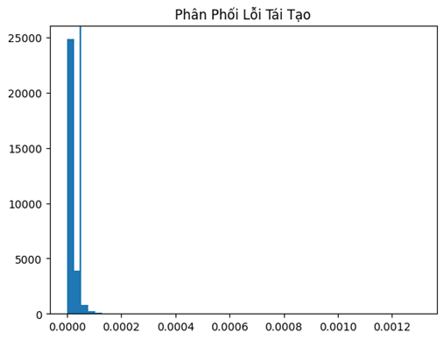
Pic 17: Phân phối lỗi tái tạo

Report and conclusion:
- Summart of Key Findings:
- Factors Influencing Stress:
Based on the training results of the Gradient Boosting Regressor and XGBoost Regressor models, it can be observed that the ability to predict Stress Level remains limited. Specifically, the coefficient of determination R² reached only about 0.11, indicating that the variables in the dataset explain only a very small portion of the variance in Stress. However, feature importance analysis shows that the most significant contributing factors are Sleep Hours and Physical Activity. This is clearly reflected in the feature importance chart, where these two factors have considerably higher importance values compared to the others. Observations from the scatter plot between Stress and Sleep Hours also reveal that shorter or poorer-quality sleep tends to be associated with higher Stress, although the relationship is not strictly linear. Thus, it can be concluded that Stress is influenced by lifestyle—particularly sleep and physical activity—but is also shaped by many psychological and environmental factors not captured in the dataset, leading to the low accuracy of the models.
- Factors Influencing BMI:
In contrast to Stress, analyses related to BMI reveal clearer and more interpretable relationships. Based on average BMI charts across physical activity levels, age groups, and gender, it can be directly observed that individuals with lower levels of physical activity generally have higher BMI. BMI also tends to increase with age, especially from middle age onwards. The difference in BMI between males and females is consistently shown in the average bar charts. These relationships are clearly visible in the visualizations and align with established medical knowledge, indicating that BMI strongly depends on physiological and behavioral factors that are easier to measure compared to Stress.
- Comparison of two tasks:
- Accuracy:
The Stress prediction task yields relatively low accuracy, as the model explains only about 11% of the data variance. In contrast, the BMI analysis demonstrates stable and consistent trends across multiple visualizations.
- Interpretability:
Stress is a subjective variable, influenced by many factors that are difficult to quantify, such as psychological state, social pressure, and work environment, making the model harder to interpret clearly. On the other hand, BMI is a physical index with direct relationships to age, gender, and physical activity, which makes it easier to analyze and explain.
- Practical Significance:
The Stress model mainly serves as a reference for identifying trends and providing early warnings, whereas BMI analysis can be directly applied in health management, lifestyle counseling, and disease prevention.

Acknowledgment
We would like to express our sincere gratitude to:
- Instructor Phạm Nguyễn Phúc Toàn, for his dedicated guidance, direction, and professional support throughout the implementation of this project.
- All team members, for their close collaboration, hard work, and successful completion of the assigned tasks.
- Data sources and reference materials from previous studies, which provided the foundation for developing our machine learning models to predict Stress Level based on BMI and other health factors.
The valuable support and contributions from our instructor, teammates, and the referenced data and materials have been an essential basis for the successful completion of this report.

References
- G.A. Ahmed, “Healthcare Risk Factors Dataset,” Kaggle, 2022. [Online].Available: https://www.kaggle.com/datasets/abdallaahmed77/healthcare-risk-factors-dataset
- Z. Sun et al., “Using interpretable machine learning methods to identify the relative importance of lifestyle factors for overweight and obesity in adults: pooled evidence from CHNS and NHANES,” BMC Public Health, vol. 24, no. 3034, 2024.
- K. Fujihara et al., “Machine learning approach to predict body weight in adults,” Frontiers in Public Health, vol. 11, 2023. [Online]. Available: https://doi.org/10.3389/fpubh.2023.1090146
- MDPI Sensors, “Quantifying Digital Biomarkers for Well-Being: Stress, Anxiety, and Depression using Machine Learning,” Sensors, vol. 23, no. 21, p. 8987, 2023. [Online]. Available: https://www.mdpi.com/1424-8220/23/21/8987
- D. P. Kingma and M. Welling, “Auto-Encoding Variational Bayes,” arXiv preprint, arXiv:1312.6114, 2013. [Online]. Available: https://arxiv.org/abs/1312.6114
- U.S. Department of Health and Human Services, “Treatment Episode Data Set Changes (TEDS-D): Concatenated, 2006 to 2009,” Substance Abuse and Mental Health Services Administration, Aug. 2013. DOI:10.3886/ICPSR30122.v2

